Alaska Dressage Association
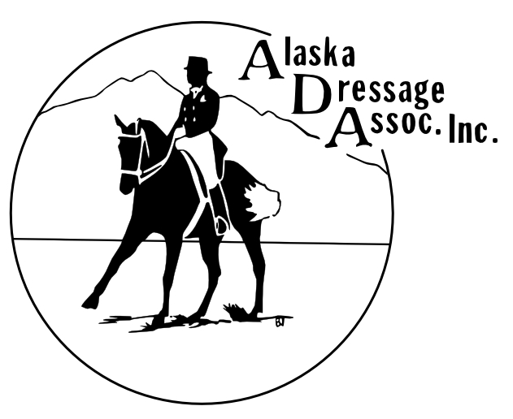
Board Meeting Agenda
June 22, 2021

Call to Order: 6:10pm

Roll Call:
Present: Brittany, Char, Rosa, Hilary, Leilani

Excused: Marcia, Lauren

Approval of Minutes from Last Meeting:

Treasurer’s Report: Balance $11399.97. Show balance -$100, Peter used his own airline miles, Ardene paid for Axel’s BnB. July’s TD airfare is carried over from last year. Need to discuss splitting airfare of Sue Kolstad with Pony Club since they are holding a clinic. $2824.45 owed to Char needs signed off on.

Open Issues (Old Business):

June Show evaluation - didn’t like 8am start, but went well overall
Feedback from participants
USDF interest - story of moose situation spreading through USDF

New Business:

Show planning status
Volunteers: Driving officials, scribes, show staff - would like to have a person responsible for scheduling judge and TD transportation. Review contracts for dietary needs, in preparation for show lunch. Scribe options – previous scribes, Victoria? Think of more people that can be show staff. See if we can get stereo working before July. In future, have individuals on show committee dedicated to working on hospitality and scheduling. Need to get Judge/TD contract initiation back within Board.
Clinic? need to publicize available opportunities at the end of the day. As well as official clinic through Pony Club, coordinate with Sharon.

Fund raising – potential events
Wine event, schooling show in Sept with Jim Briggs?
Banquet – Petroleum Club without membership? Need to reserve
Fred Meyer community give back is good to proceed
Paint nite, restaurant donation event

Grant opportunities - available for organization and members

Adjourn: 6:51pm

Next ADA Board Meeting:

