Alaska Dressage Association
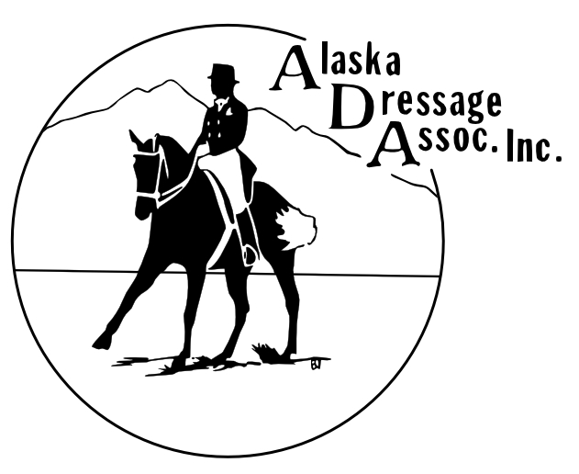
Board Meeting Agenda
April 20, 2021

Call to Order: 6:05pm

Roll Call:
Present: Rosa, Brittany, Char, Sharon, Hilary, Killian, Leilani, Marcia

Excused: Lauren

Approval of Minutes from Last Meeting:

Treasurer’s Report: Paid: Chamberlain, security deposit, insurance for first show paid. Need to pay Fox Village, Ribbons, Deana for GMOs.

Open Issues (Old Business):

Show planning status (Ribbons, Show sheets) Ribbons: Char and Hilary will finalize
EMT – how much to pay? $175 with lunch
Lodging for judges set up by Ardene Eaton – 2 nights only for judges
Vets – Wellington and Neu - $175
Omnibus – ready for review in Teams
Handbook – Motion to adopt final changes, approved. Please review Handbook and Bylaws in Teams
New Business:

Ride-a-test at Diamond H - May 22 approved, Rosa to verify with Linda
Setup arena May 15th
Valley activities? Wait for Lauren
Event at Zo’s? Shelby willing to help with paperwork talk if it works out. Maybe do something in the fall or a couple days after Sue Kolstead’s show instead? Make it a midsummer educational event

Adjourn: 7:21pm

Next ADA Board Meeting: May 18 in person? At Center

